Bourbon, Scotch, Whiskey  Bourbon  Jim Beam  Woodford Reserve  Red Stag  Makers Mark  Makers 46  High West  Scotch  J&B  Dewar’s White Label  Johnny Walker Black  Johnny Walker Red  Glenfiddich  Maccallan 12 year  Highland Dark Magnus  Chivas Regal  Whiskey  Jack Daniels  Segrams 7  Canadian Club  Jameson  Tyrconnell  Crown Royal  Southern Comfort  Bulleit Rye |  | Drink Menu  Tavern on the green  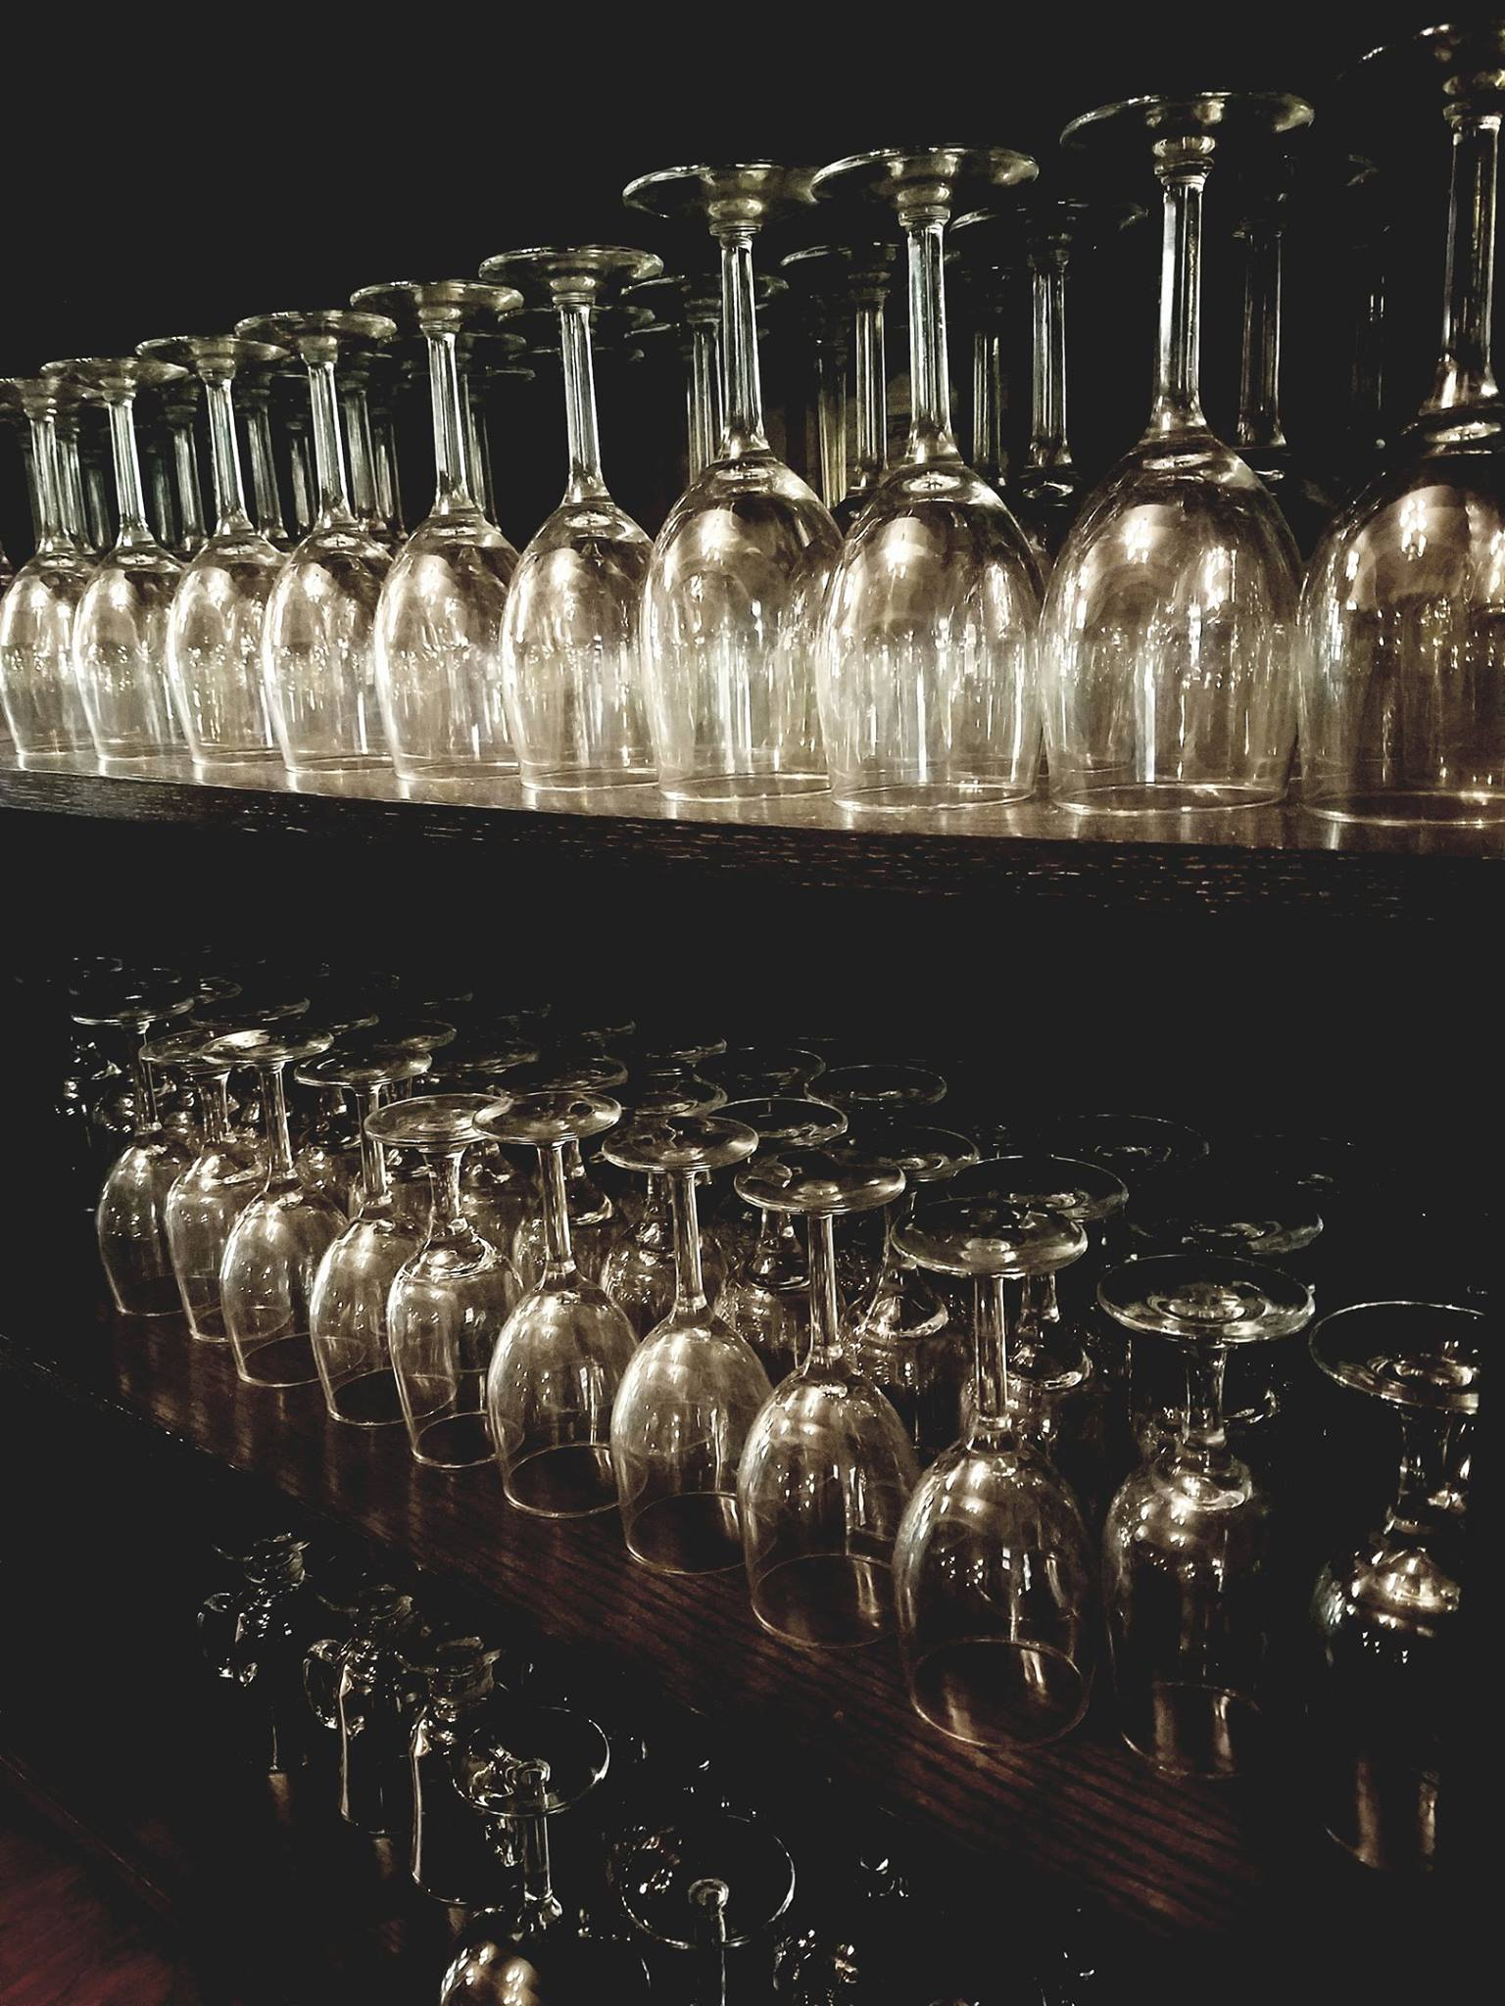
Cocktails  Old Fashion 8  Makers Mark, muddled oranges & cherries, bitters, soda water  Gin Fizz 9  Hendricks, lime juice, egg white, soda water  Zombie 7  Apricot Brandy, pineapple juice, lime juice  Autumn Moscow Mule 7  House-infused vodka, ginger beer, apple cider  Red Velvet Cake Martini 12  Frangelico, Grand Marnier, Skyy vodka, Crème de cacao, Grenadine  Whiskey Sour 8  Bulleit Rye, lemon juice, egg white  Paloma 7.5  Milagro, grapefruit soda, lime juice  Blood Orange Martini 10  Skyy blood orange, pineapple juice, orange juice, grenadine | White Wine  Hand Craft Chardonnay 6  Hand craft Pinot Grigio 6  Esperto Pinot Grigio  Italy, 2016…8.5/32  Lobster reef Sauvignon blanc  New Zealand, 2017…10/38  Fess parker riesling  Santa Barbara, 2017…9/37  Aime Roguesante cotes de provence  France, 2017…10/38  Menage a Trois  California, 2016…8/32  Luna Pinot Grigio  California, 2015…18  Lunatic White  California, 2014…40  Pennywise  California, 2012…19 | Red Wine  Hand Craft Cabernet  Hand Craft Pinot Noir  Moobuzz cabernet  Paso Robles, 2016…11/40  Cigar Box pinot noir  Chile, 2015…8/32  Cigar box Malbec  Argentina, 2016…8/32  The Velvet Devil Merlot  Washington, 2016…9/37  Menage a Tois  California, 2016…8/32  Plungerhead old vine zinfandel  Lodi, 2016…11/40  The Prisoner  Napa Valley, 2016…70  Mollydooker the scooter merlot  Australia, 2016…60  Pence ranch pinot noir  Santa Barbara, 2016…40
