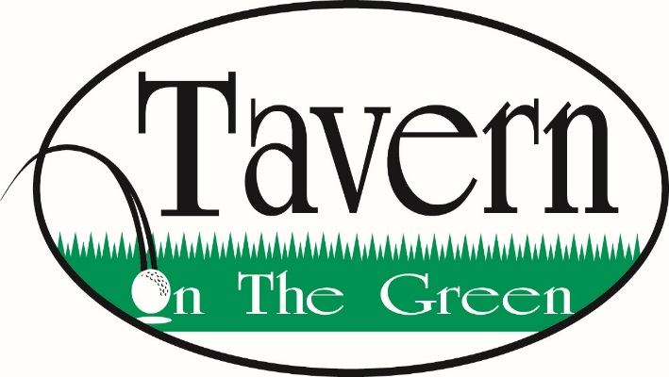

Small Plates

Loaded Potato Skins…8
Blackened Steak Bites…$12
Served over fried onions w/ horseradish cream
Chicken Wings…$13
Buffalo, BBQ, Spicy Garlic, Thai Chili, Parmesan Garlic, Bourbon Glaze, Honey Garlic, Schezwan w/ sesame seeds
Home-made Beer Battered Cheese Curds …$9
Served with House made marinara
Smoked Salmon Dip…12
Cream Cheese, Jalapeno, bacon, dill
Coconut Thai Chili Shrimp…12
8 Jumbo Shrimp sautéed with garlic and simmered in a sweet and spicy Thai chili sauce
Trio Pork Belly Tacos…11
-Lettuce & Strawberry Salsa
- Lettuce & Pineapple Salsa
-Lettuce, Tomato & Colby Jack Cheese
Sandwiches & Burgers
Served with your choice of one side

Pot Roast Sandwich…11
With pepper jack cheese on an onion bun, served with a side of natural Jus
Spicy Fried Chicken Sandwich…13
Tabasco marinated chicken breast, cheddar cheese, and bacon with sriracha mayo and drizzled with garlic honey. Served with lettuce, tomato, and onion on side.
Cod Sandwich…10
Guinness Battered Cod, house-made tarter, lettuce on a pretzel bun
Classic Hamburger…11
8oz steakhouse patty, lettuce, tomato, and onion. Served on a pretzel bun.
Add Cheese $0.50 Add Bacon $1.00

The Big Tasty…14
8oz steakhouse patty, bacon, onion straws, ghost pepper jack cheese, American cheese, blue cheese dressing, bourbon glaze on a pretzel bun
19th Hole Jam burger…14
8oz steakhouse patty, bacon jam, goat cheese, onion straws, arugula tossed in a lemon vinaigrette
Steak Sandwich…17
Chopped steak w/ peppers onions and mushrooms, served with provolone cheese
Buffalo Chicken Wrap…12
Grilled chicken, bacon, cheddar cheese, lettuce, tomato, onion, spicy garlic buffalo sauce, and ranch
Chicken Caesar Wrap…11
Grilled Chicken, romaine lettuce, tomato, parmesan cheese, and caesar dressing

Salad

Smoked Salmon Caesar…14
Romaine Lettuce, parmesan cheese, Caesar dressing
Chop Salad…10
Iceberg lettuce, olives, blue cheese, bacon, tomatoes, garbanzo beans, Italian dressing
Prosciutto Salad…12
Arugula, tomato, mozzarella cheese, balsamic dressing
Grilled Peach Salad…9
Arugula, blueberries, red onions, blue cheese, almonds, lemon vinaigrette
Pasta
Served with your choice of soup or salad
Beef Stroganoff…17
Beef tips, house-made mushroom gravy, egg noodles
Chicken Parmesan…16
Breaded chicken breast, topped with parmesan cheese, over linguine noodles and house-made marinara sauce
Garlic Pesto Linguini…13
Spinach, tomatoes, mushrooms, tossed in a garlic pesto oil. Add grilled chicken $4 Shrimp $6
Cajun Chicken Alfredo…16
Blackened chicken, broccoli, red peppers, yellow peppers, Cajun Alfredo, over linguini noodles

Steaks & Chops
Served with your choice of soup or salad, daily vegetable and one side
Pork Chops…28
Served with a pineapple glaze
10 oz Filet Mignon…32
12 oz Ribeye Steak…34
12 oz New York Strip…36
20oz Porterhouse…42
Steak Add-ons
Blue Cheese or Parmesan Crusted…2
Mushrooms, Onions or Peppers…2.5
Jumbo Shrimp…6
Garlic Butter…1

Seafood
Served with your choice of soup or salad, daily vegetable and one side

Pan seared Halibut…24
Served with Lemon basil cream
Thai Chili Glazed Salmon…26
Sautéed jumbo shrimp
Shrimp Scampi…22
8pc Jumbo Shrimp sautéed in garlic and served with lemon white wine butter sauce
Fried Perch…24
Lightly breaded and deep fried
Guinness Battered Cod…18
Sides
French Fries, Seasoned Waffle Fries
Chips, Potato Skins…2
Truffle Parmesan Fries…1

